Please complete this survey:
Have you been to a St Johnstone FC Game before: YES / NO
If yes, how often:

If no, what has put you off going to a game?


Have you ever experienced homophobia or transphobia at a football game: YES / NO
Give Details:

What could St Johnstone FC do to make LGBTQ+ fans more welcome?

The fans group for LGBTQ+ Supporters of St Johnstone FC.
Many LGBTQ+ fans are discouraged from going to football games because they have no one to go with or because they fear the atmosphere on the terraces will not make them feel welcome.
PROUD SAINTEES aims are to:
- Foster a safe place for LGBTQ+ Fans at St Johnstone FC
- Encourage more LGBTQ+ Fans to attend games
- Provide a LGBTQ+ voice at St Johnstone FC
- Maximise opportunities for LGBTQ+ visibility in Football
- Champion social activity and build a sense of community

- Challenge hate on the terraces in all forms
This leaflet has been printed with support from the St Johnstone Community Trust.


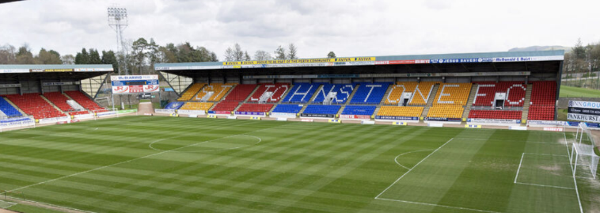
St. Johnstone FC has a proud record of supporting the local community.
LGBTQ+ supporters are part of that community. PROUD SAINTEES aim to work closely with the club to make sure that St Johnstone FC is a safe space for LGBTQ+ fans.


PROUD SAINTEES will work with the St. Johnstone to help it implement the Scottish Sports LGBT Charter.

PROUD SAINTEES will offer social opportunities where LGBTQ+ fans can get together to share out love for the Saints. This may include pre or post match get togethers and view parties for St Johnstone games shown live on BBC Scotland.

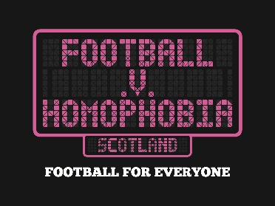
PROUD SAINTEES wants football to take a clear stand against homophobia and transphobia so that everyone can enjoy watching St. Johnstone. We will challenge hate on the terraces, and work with St Johnstone to stamp it out.
PROUD SAINTEES will promote campaigns like Rainbow Laces and Football v Homophobia Month,

PROUD SAINTEES will seek to find ways to encourage more LGBTQ+ fans to attend games. This might include a “buddy” system for those anxious about attending for the first time; LGBTQ+ fan days for home or away games.

PROUD SAINTEES would like to thank St Johnstone FC for providing our banner and Pop-up and RYSE Together for the design.
PROUD SAINTEES acknowledges the support of:
St Johnstone Football Club; Saints in the Community; Perth Parrots; Rainbow Heartlands; Perthshire Pride; Leap Sports; Perth and Kinross Council.

What should the priorities of PROUD SAINTEES be (mark 1.2.3. etc)?
- Challenging hate & homophobia
- Encouraging more LGBTQ+ fans to attend games
- Social activities
- Foster a safe space
- Provide a LGBTQ+ Voice at St Johnstone FC
- Maximising LGBTQ+ visibility
What sort of activities would you like PROUD SAINTEES do?

I would like to be added to the PROUD SAINTEES mailing list:
Name:

Email:

Return to
Proud Saintees, 14 Melville Road. Ladybank. Cupar.Fife, KY15 7LU.

